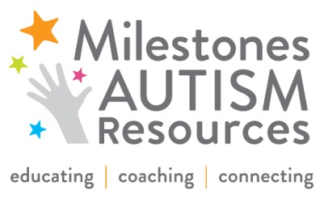
FOR IMMEDIATE RELEASE
Milestones receives grant from the Martha Holden Jennings Foundation to offer autism training for First Ring School Districts

July 14, 2014
CLEVELAND – Milestones Autism Resources will host Milestones School Team Training on August 4-8, 2014 from 8:30 a.m. to 4:30 p.m. at Canterbury Elementary School in Cleveland Heights. While all districts are encouraged to attend, First Ring School personnel can register at a deeply discounted rate, thanks to a grant from the Martha Holden Jennings Foundation presented to Milestones.

Milestones School Team Training is a week-long, hands-on professional development opportunity focused on evidence-based classroom techniques for students with autism in preschool through high school. Intervention specialists, paraprofessionals, school administrators, speech-language pathologists, school psychologists and occupational and physical therapists are invited to attend.

“I have been teaching for 14 years and consider myself a master teacher but never really had behavioral strategies to use before attending this training,” Renee Schonhiutt, past attendee and intervention specialist at West Geauga Local Schools, said. “It’s been the best training of my career.”

Participants will learn how to work collaboratively to improve student outcomes and performance, reduce problem behaviors using the principles of Applied Behavioral Analysis (ABA), manage and structure the classroom to promote independence, improve IEP writing skills and data collection procedures and motivate students for success using proven reinforcement strategies.

School districts that are eligible for the grant-funded discounted rate are Bedford, Berea, Brooklyn, Cleveland Heights-University Heights, Cuyahoga Heights, East Cleveland, Euclid, Fairview Park, Garfield Heights, Lakewood, Maple Heights, Parma, Richmond Heights, Shaker Heights, South Euclid-Lyndhurst, Warrensville Heights.

Limited spaces are still available, and pre-registration is required. To register, visit milestones.org or contact Leslie Rotsky at lrotsky@milestones.org or by calling (216) 464-7600.

In addition, scholarships are available based on need.

About Milestones Autism Resources
Founded in 2003, Milestones Autism Resources, previously known as Milestones Autism Organization, helps individuals with autism throughout Northeast Ohio reach their unique potential and is the first call for help at each transition of an individual’s life. Milestones focuses on educating and coaching for family members and professionals in evidence-based practical strategies. Its conferences, workshops, professional development, referral calls and online resources connect the autism community with vital information, and each other. Each year, Milestones serves 1,500 individuals. Its website, milestones.org, connects 34,000 unique visitors to more than 900 autism resources.

Media Contact:
Britney Beaman
Communications Coordinator, Milestones Autism Resources
216.464.7600 x113
blbeaman@milestones.org

###

