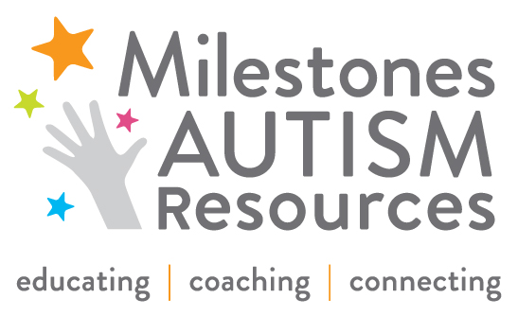

FOR IMMEDIATE RELEASE Contact: Britney Beaman
June 10, 2014 Office: 216-464-7600
Cell: 330-429-0980
blbeaman@milestones.org

MEDIA ALERT:

CLEVELAND-BASED MILESTONES AUTISM RESOURCES HOSTS 12th ANNUAL AUTISM SPECTRUM DISORDER CONFERENCE AT IX-CENTER
Parents and professionals unite to learn, teach, connect and support each other at one of the country’s largest annual autism spectrum disorder conferences

WHAT: Milestones Autism Spectrum Disorder Conference is a two-day event presented by Cleveland-based Milestones Autism Resources (milestones.org) that brings family members and leading experts in the field of autism together to share evidence-based practical strategies and best practices.

Attendees engage in 75-plus educational workshops focusing on field-tested ideas, and national keynote speakers present leading-edge research, concepts and strategies. Forty-five exhibitors will showcase local autism products and services at the conference.

New this year:
- Employment Track – Area employers will learn about new federal and state mandates to hire individuals of all abilities. Workshop sessions focus on strategies to support adults with ASD in the workplace.
- Medical Track – Leading physicians will present on research and treatments that improve the outcomes of patients with ASD. Medical professionals will learn how to make visits to their office more autism friendly.
- Exclusive parent features – Parents are welcomed in a designated check-in area with staff available to coach them in selecting which workshops to attend. Dozens of sessions cover family concerns and special networking luncheons provide opportunities for parents to meet and learn from each other’s successes.

Complete conference information is available at http://milestones.org/what-we-do/conferences/.

WHEN: Wednesday, June 18 through Thursday, June 19, 2014
8:00 a.m. – 5:00 p.m.

WHERE: Cleveland I-X Center
1 I-X Center Drive
Cleveland, Ohio 44135

INTERVIEW
OPPORTUNITY: Milestones staff: Our professional leaders are Cleveland-based experts in autism spectrum disorder.
Speakers: More than 100 speakers from across the country will present groundbreaking research and evidence-based strategies. To view the workshop topics and speakers, visit milestones.org.

Contact Britney Beaman to schedule interviews with Milestones staff and speakers.

REGISTRATION: Reporters and editors are invited to attend free of charge. RSVP to Britney Beaman: Office: 216-464-7600; Cell: 330-429-0980; blbeaman@milestones.org.

###

