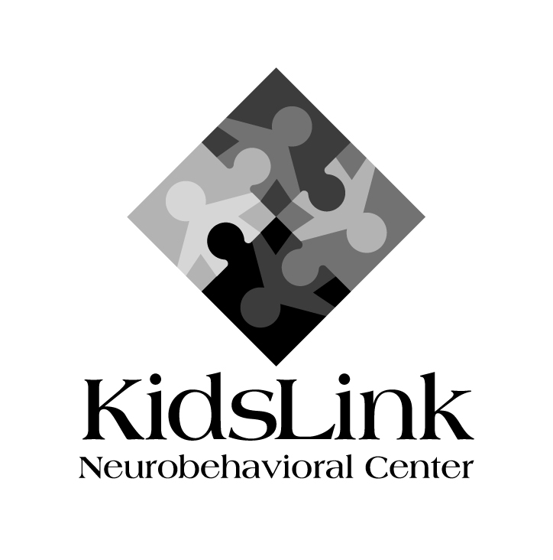
KidsLink Neurobehavioral Center
2132 Case Parkway North
Suite A
Twinsburg, OH 44087

330-963-8600

www.kidslinkohio.com

Join Our Team!

We’re currently looking for individuals to work in our Kidslink School one on one and in small groups with children with Autism spectrum and related disorders.

Openings for both full and part time positions

Behavioral Therapist/Tutor

- Experience with children with special needs required/preferred
- Kidslink will provide on-site training in behavior analysis
- Pay range is $16-$20 per hour.

About Kidslink Neurobehavioral Center:
At KidsLink, we have a full team of professionals to link the pieces of treatment, for total care of children. We believe that…
- Children with neurological and psychological diagnoses need a coordinated team of medical and related service professionals to provide total care for their diverse needs.
- Treatment services must be individualized and provided in a child-friendly environment.
- Family support and education is critical to the success of children with special needs.
- Recreational and leisure activities are important to promote social, communication and daily living skills, as well as to enhance quality of life.
Please contact us if you are interested in providing us with your resume.

Kidslink Neurobehavioral Center  330-963-8600 | Kidslink Neurobehavioral Center  330-963-8600 | Kidslink Neurobehavioral Center  330-963-8600 | Kidslink Neurobehavioral Center  330-963-8600 | Kidslink Neurobehavioral Center  330-963-8600 | Kidslink Neurobehavioral Center  330-963-8600 | Kidslink Neurobehavioral Center  330-963-8600 | Kidslink Neurobehavioral Center  330-963-8600 | Kidslink Neurobehavioral Center  330-963-8600 | Kidslink Neurobehavioral Center  330-963-8600

