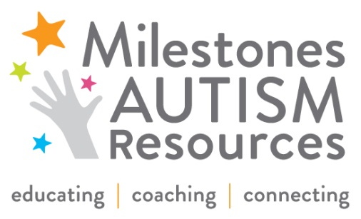
Milestones 2015 Corporate Leadership Awards Nomination Form
Deadline: January 15, 2015

Milestones Autism Resources annually presents Corporate Leadership Awards to large, mid-size, and small companies that have created a supportive place of employment, encouraging individuals of all abilities to be included as part of the overall staff community. Awards are presented at our annual June Conference.
Please nominate a company or individual you think is deserving of one of the following awards:
____ Large Company Award (500+ employees)

____ Mid-Size Company Award (140-499 employees)

____ Small Company Award (25-149 employees)

Person/Company You Are Nominating:
___________________________________________________________________________________________

Nominee’s Title, Affiliation & Credentials:
___________________________________________________________________________________________

Email: ________________________________________ Phone:__________________________________

Your Name: ___________________________________ Connection to Nominee: ___________________

Your Title, Affiliation & Credentials: ___________________________________________________________________________________________

Email: ________________________________________ Phone:__________________________________

The following questions will guide the selection process. Please answer completely and provide specific examples about the person/company you are nominating. You can use additional space as needed.

Why do you feel this person/company deserves to be recognized?

What has this person/company done to support employees with special needs, especially developmental disabilities?

What is the total # of employees at this company? ______

Approximately how many people with disabilities have been hired at this company? ______

Please submit completed form to Leslie Rotsky at lrotsky@milestones.org or by fax to 216.464.7602. Thank you!

