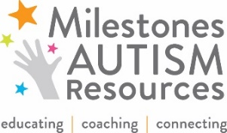
2018 Milestones National Autism Conference
Scholarship Application for FAMILY MEMBERS,
FULL-TIME STUDENTS, and INDIVIDUALS WITH ASD
Deadline June 4, 2018 | One application per person
Milestones is committed to offering as many scholarships as possible for our conference on June 14-15, 2018 based on financial need. We ask you to contribute as much as you can afford. Please let us know if you can afford half of the fee: $25 individuals with ASD or students, $80 for family members. If this is beyond your means, consider paying a smaller portion of the fee: $15 individuals with ASD or students, $55 for family members. Scholarships will be awarded on a first-come, first-served basis.
Parents: Before submitting this application, first contact your Support Administrator at your County Board of Developmental Disabilities to see if this conference can be funded with Family Support Dollars.
Child Policy: We are unable to offer child care. If your older teen/young adult is able to benefit from the sessions and sit through them without disruption, we are happy for you to submit an application for him/her.
New This Year! Breakfast, lunch and parking are complimentary for all attendees.
Name:
Address:
Email: Home Phone: Cell:
Employer and Address:
I would like to attend: ☐ Thursday, June 14th ☐ Friday, June 15th ☐ Both Days
I will be there for: ☐ Breakfast ☐ Lunch Dietary Needs: ☐ no dairy ☐ no gluten ☐ vegan ☐ vegetarian
Registration Category: ☐ Parent ☐ Other Family Member ☐ Individual with ASD ☐ Full-Time Student
How did you hear about the conference?
Amount you are able to contribute toward your registration $ _______________
Please describe why you would like to attend the conference, what you hope to gain from it, and why you are applying for scholarship assistance.

