NEW RECREATION PROGRAMS FROM SOAR!

GET MOVING AND JOIN THE FUN TODAY!

(MAY 29th – JULY 3rd)

Join us for the next session of SOAR! Spring/Summer activities! In addition to the popular walking programs, meet us at the Gemini Center for our Dancercize class! Meet at Big Creek Center for the ever-popular aerobics class or, play bocce ball at the Rocky River Adult Activities Center on Friday nights……There’s something for everyone so sign up today!
MONDAYS | TUESDAYS |  |  | WEDNESDAYS |  | THURSDAYS |  | FRIDAYS
DANCERCIZE: 6:30 – 7:30PM  Where: Gemini Center,  21225 Lorain Road  (Just West of 210th Street) | WALKING: 6:30-7:30 PM  Where: Rocky River Reservation,  Rockcliff Spring Parking lot. (1¼  miles south of Detroit Road park entrance) |  |  | AEROBICS: 6:30 – 7:30 PM  Where: Big Creek Center (6149 West 130th Street) |  | WALKING: 6:30 – 7:30 PM  Where: Brooklyn Memorial Park (7727 Memphis Avenue) |  | BOCCE BALL:  6:00 – 7:30 PM  Where: Rocky River Adult Activities Center (20120 Detroit Road)
Description: Join us for an active hour of moving and grooving. Guaranteed to be a great (and FUN!) workout so shake it out!....Sign up today.  Limited to 40 participants | Description: Experience late Spring and early Summer with your walking friends at SOAR! Take a leisurely stroll or ‘step it out’ ….whichever you prefer!  Limited to 30 participants |  |  | Description: Join this popular activity with Angie. Listen to great tunes while we work on strength, endurance & flexibility. Always a great time… see you there!  Limited to 45 participants |  | Description: Stroll through the beautiful, paved, Memorial Park setting for a wonderful evening out! Perfect for walkers, wheelchairs and anyone that wants to join in!  Limited to 30 participants |  | Description: Join us for a fun time as we enjoy the great game of bocce ball! Anyone can play so start your weekend with your friends at SOAR!  Limited to 20 participants
Dates:  June 4th, 11th, 18th & 25th  July 2nd | Dates:  May 29th, June 5th, 12th  19th, 26th & July 3rd |  |  | Dates:  May 30th, June 6th, 13th,  20th & 27th |  | Dates:  May 31st, June 7th, 14th,  21st & 28th |  | Dates:  June 1st, 8th, 15th & 22nd
Fee: $20. | Fee: $12. |  |  | Fee: $20. |  | Fee: $12. |  | Fee: $15.
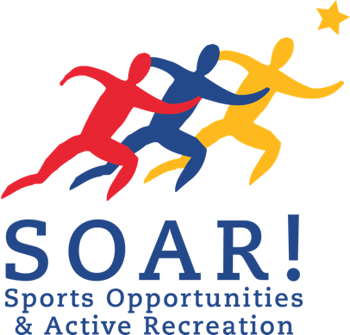
(Fee includes: snacks at each activity)

Registration Deadline is Wednesday, May 23rd, so sign up today!!!

FOR ADDITIONAL INFORMATION OR TO REGISTER FOR AN ACTIVITY CALL US AT: (440) 327-6454

Mail completed *form and registration fee to: SOAR!, 32730 Walker Road – Suite I - 1, Avon Lake, Ohio 44012
*If not on file for the current year
WWW.SOARprograms.org

