JOIN THE SUMMER FUN WITH SOAR!

DON’T MISS OUT…….SIGN UP TODAY!

(JULY 16th – AUGUST 24th )

Summer’s in full swing so join us for any/all of our activities. There’s something for everyone! In addition to the popular walking programs, we’ll also be meeting in the park on Mondays for Outdoor Games. Or, meet at the Big Creek Center for our popular aerobics class or, play bocce ball at the Rocky River AAC on Friday evenings!
MONDAYS | TUESDAYS |  |  | WEDNESDAYS |  | THURSDAYS |  | FRIDAYS
OUTDOOR GAMES : 6:30–7:30PM  Where: Big Creek Reservation  (Snow Road & Big Creek Parkway) | WALKING: 6:30-7:30 PM  Where: Rocky River Reservation,  Rockcliff Spring Parking lot. (1¼  miles south of Detroit Road park entrance) |  |  | AEROBICS: 6:30 – 7:30 PM  Where: Big Creek Center (6149 West 130th Street) |  | WALKING: 6:30 – 7:30 PM  Where: Brooklyn Memorial Park (7727 Memphis Avenue) |  | BOCCE BALL:  6:00 – 7:30 PM  Where: Rocky River Adult Activities Center (20120 Detroit Road)
Description: Join us for a variety of games to test your skills….. bocce ball, baggo, wiffleball, kickball, target toss and some new games too!  Limited to 30 participants | Description: Experience late Spring and early Summer with your walking friends at SOAR! Take a leisurely stroll or ‘step it out’ ….whichever you prefer!  Limited to 30 participants |  |  | Description: Join this popular activity with Angie. Listen to great tunes while we work on strength, endurance & flexibility. Always a great time… see you there!  Limited to 45 participants |  | Description: Stroll through the beautiful, paved, Memorial Park setting for a wonderful evening out! Perfect for walkers, wheelchairs and anyone that wants to join in!  Limited to 30 participants |  | Description: Join us for a great time as we enjoy the great game of bocce ball! Anyone can play so start your weekend with your friends at SOAR!  Limited to 20 participants
Dates:  July 16th, 23rd, 30th  August 6th, 13th & 20th | Dates:  July 17th, 24th, 31st  August 7th, 14th & 21st |  |  | Dates:  July 18th, 25th  August 1st, 8th, 15th & 22nd |  | Dates:  July 19th, 26th  August 2nd, 9th, 16th & 23rd |  | Dates:  July 20, 27th  August 10th & 24th
Fee: $15. | Fee: $12. |  |  | Fee: $20. |  | Fee: $12. |  | Fee: $15.
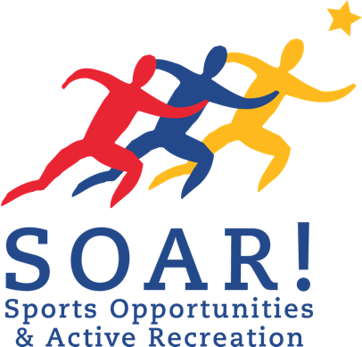
(Fee includes: snacks at each activity)

Registration Deadline is Thursday, July 5th, so sign up today!!!

FOR ADDITIONAL INFORMATION OR TO REGISTER FOR AN ACTIVITY CALL US AT: (440) 327-6454

Mail completed *form and registration fee to: SOAR!, 32730 Walker Road, Suite I-1, Avon Lake, Ohio 44012
*If not on file for the current year

WWW.SOARprograms.org

